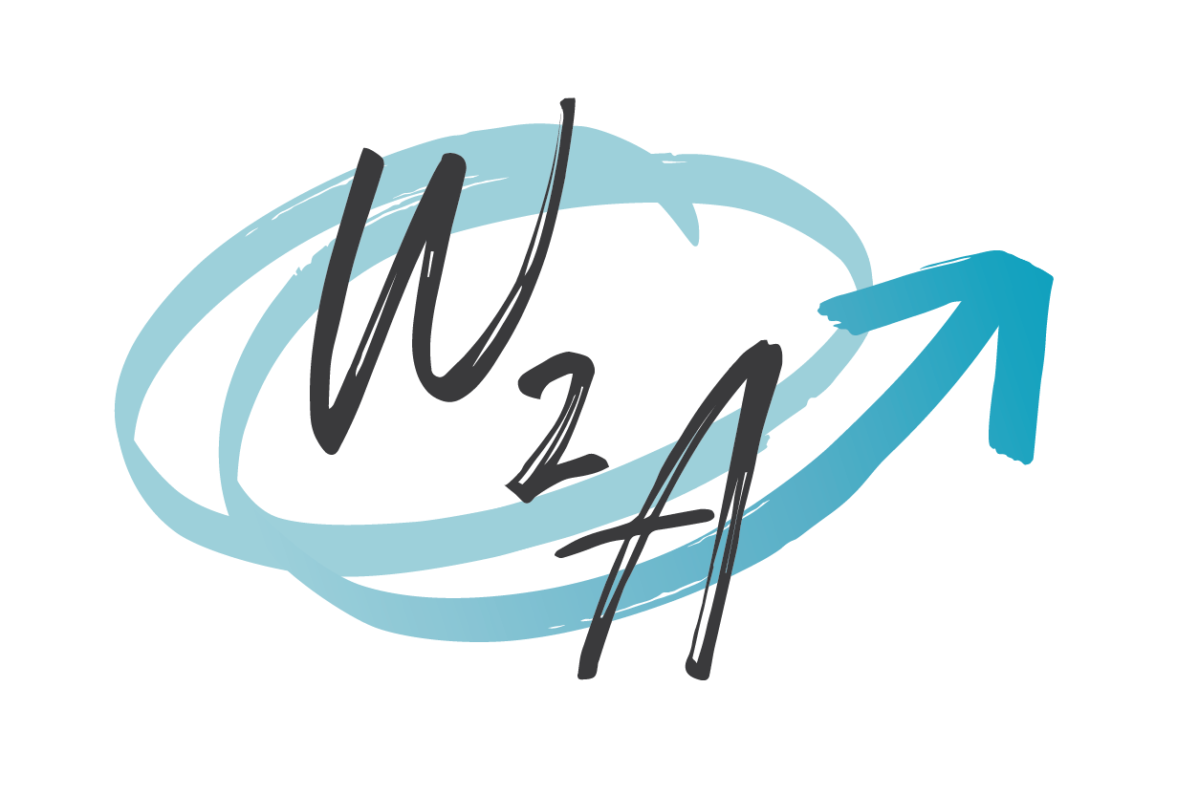

**WISDOM2ACTION - WE’RE HIRING!**

**Part-time Project Officer**

Remote/home-based - from anywhere in Canada

9-month term - possibility of extension

1 day/week in September increasing to 3 days/week in October

Flexible schedule

$60,000 - $64,000/year (pro-rated) depending on experience

Optional health benefits with shared employer contributions

**ABOUT WISDOM2ACTION**

Wisdom2Action (W2A) is a consulting firm and social enterprise working to facilitate positive change and strengthen communities. Our work addresses a number of themes and takes multiple forms. We primarily focus on gender justice and 2SLGBTQ+ inclusion, children’s rights and youth engagement, and mental health. Our services include capacity building and organizational development, community and stakeholder engagement, and research and knowledge mobilization.

W2A initiatives are aligned with, and guided by, our organizational values. Our work is based on evidence, driven by community engagement, and committed to addressing and preventing oppression in all its forms.

W2A was founded in Kjipuktuk (Mi’kma’ki)/Halifax, Nova Scotia, the traditional and unceded territory of the Mi’kmaq. Our team works remotely, from a variety of locations across Turtle Island/Canada, spanning the traditional and unceded territories of many nations and treaty areas.

**ABOUT THIS ROLE**

We are seeking applications for the part-time position of **Project Officer** for a 9-month term (with the possibility of extension). The position will be conditional on a successful three-month performance review. The position will be remotely located (home-based, no relocation required or supported) and is open to all qualified applicants legally eligible to work in Canada. The position will begin in September, one day per week (7.5hrs/20% FTE) then increase to three days per week in October (22.5hrs/60% FTE) dependent on grant funding. The schedule is flexible with most hours to be completed Monday through Friday during regular (Eastern or Atlantic time zone) business hours. The annual salary will be between $60,000 and $64,000/year (pro-rated), dependant on experience. Wisdom2Action offers an optional health benefits package.

The focus of the work includes managing and coordinating multiple projects and activities with diverse 2SLGBTQIA+ communities, as well as other clients and partners, in other W2A thematic areas (children’s rights and youth engagement, mental health and substance use). The role requires strong communication and time management skills. The new Project Officer would work independently, from their own location, but in collaboration with other team members, clients, and partners. Some, infrequent travel (within Canada) may be required (to be determined).

**ABOUT YOU**

You are committed to anti-oppression, and evidence-based work that is driven by community. You are excited about supporting others, community-based research, and ensuring effecting implementation of activities to achieve positive results. You have 4 or more years of demonstrated experience in project management. Your qualifications include:

**Essential Experience:**

* Strong time management skills with the ability to coordinate multiple activities simultaneously
* Managing relationships with diverse stakeholders and clients
* Coordinating community-based, qualitative research using intersectional analysis
* Tracking and managing budgets
* Strong communication skills with the ability to clearly share information in proficient English
  + in writing, through reports, workplans, timelines, Gannt charts, and other project documents
  + verbally, in-person and using Zoom, by leading partner meetings, and providing updates to multiple stakeholders with diverse needs and knowledge levels
* Ability to work independently with a collaborative work ethic
* Commitment to social justice, equity, diversity, and inclusion as well as experience implementing approaches guided by these principles.

**Assets**

* Experience using photovoice and/or other visual research methods, methodologies and/or techniques
* Experience monitoring and evaluating projects or community-based initiatives
* Experience developing and delivering training
* Experience in graphic design, developing communications materials, social media shareables
* Proficiency in both English and French.

**If this sounds like you, please apply! We’re excited to have a new member join our team.**

W2A is committed to employment equity and encourages applications from individuals impacted by colonialism, racism, classism, sexism, able-ism, trans-phobia, homophobia, bi-phobia, and other forms of oppression. The bulk of the work for this role will focus on engagement with diverse 2SLGBTQIA+ communities. Preference will be given to applicants who identify as Black, Indigenous, or racialized 2SLGBTQIA+ community members. Applicants are invited to voluntarily complete the Self-identification form posted with this advertisement.

Please submit your application in a single document (.docx or PDF format) and include a cover letter explaining how you meet the requirements of the position and why you want to work with Wisdom2Action, your C.V., and contact information for two professional references by **26 August 2024 at 5:00PM (Atlantic)**.

Applications should be submitted to [info@wisdom2action.org](mailto:info@wisdom2action.org) with “**Project Officer Aug 2024 Application**” in the subject line of the email.

Only short-listed candidates will be contacted to arrange an interview.